FAUGHANVALE PRIMARY SCHOOL
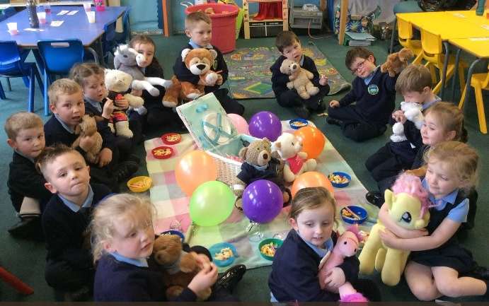
PROSPECTUS 2018

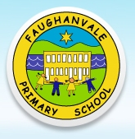
3 Vale Road
Greysteel
Co. Derry
Principal: Mrs A McGroarty
Telephone: 02871810529
Email: info@faughanvale.derry.ni.sch.uk
Website: www.faughanvaleps.co.uk

OUR MISSION STATEMENT

TOGETHER WE LEARN AND GROW

At Faughanvale Primary School we promise to create a safe and happy environment so that our pupils can learn to their full potential. At all times, the interests of our pupils are paramount. This is a Catholic school and our ethos will reflect all the positive aspects of this tradition. We are committed to maintaining a high standard of education. This includes:

A love of God and each other.

A love of the world in which we live and a growing respect for how we should look after it.

A love of life-long learning in all its strands.

Everyone who attends Faughanvale will be treated with respect and dignity to secure self-esteem. We will cherish, protect and guide all our pupils in order to safeguard values that they will carry forward in their future lives.

As a Rights Respecting School, we place considerable emphasis on how children learn about their rights, the rights of others at school and at home and across the world.

We will help them to realise their responsibility to society both locally and globally.

HISTORY OF FAUGHANVALE P.S.

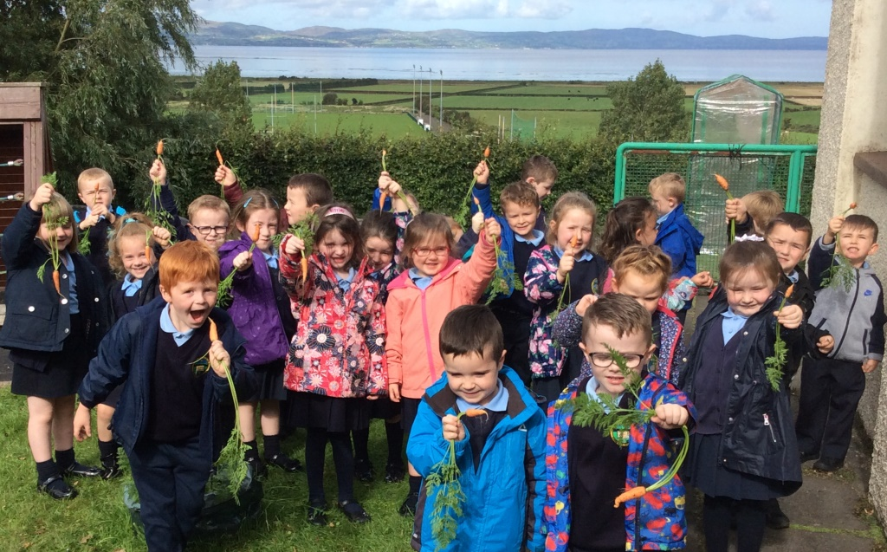

Faughanvale Primary School was opened in 1967 to serve the Parish of Faughanvale. It replaced the former Faughanvale Primary School built on the Dunlade Road. It now stands on an elevated site on the Vale Road, overlooking an impressive and awe-inspiring view of the shores of Lough Foyle and the Inishowen Peninsula. It is situated 100 metres off the main Ballykelly to Derry route, being 3 miles from Ballykelly and 10 miles from Derry.

The school was extended in 1973 and now has 8 spacious classrooms, a library, a computer room and learning support rooms. The Foundation Stage classrooms, which are situated on the ground floor, have ample toilet facilities and cloakroom areas. The first floor accommodates P4 – P7 classrooms with cloakroom areas and toilet facilities outside the rooms. One classroom on the first floor has been renovated with provision made to support children with hearing impairment. The school has Interactive Whiteboards in all the classrooms. Water fountains are available on both floors. There is a large assembly hall/dining room with an integral stage, which offers many opportunities for school plays. Healthy, well-balanced dinners are cooked in the school kitchen and served each day. We operate a cafeteria system so choice is available to all on a daily basis.

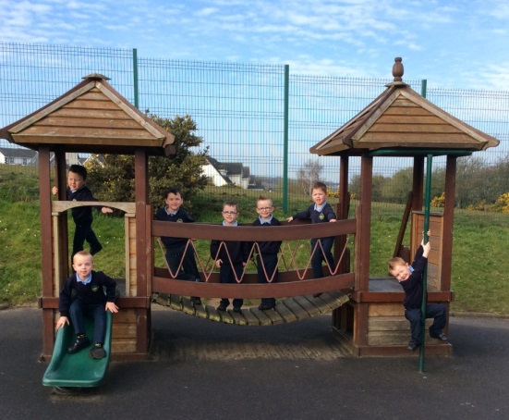
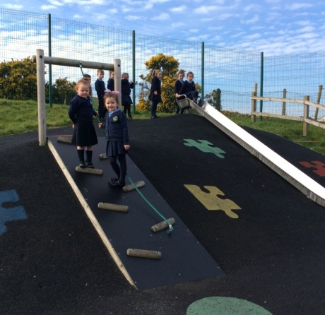
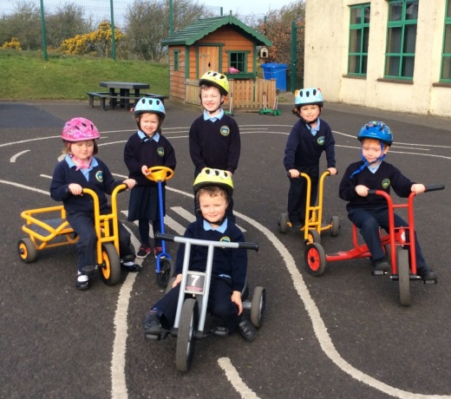

The spacious school grounds are laid out for Foundation Stage, KS1 and KS2 playgrounds. These areas are designed to encourage children to interact and enjoy playing games using the playground and wall markings. The Foundation Stage Play area has a free standing playhouse and climbing and sliding equipment which makes best use of the natural surroundings. A trim trail has been built to the front and side of the school. This is used by all year groups. There is also a spacious grassy area for football, an outdoor pond and a car parking area for staff and visitors alike. An additional car park is available with direct access to the playground. Other car users can park safely outside the school by the kerb-side.
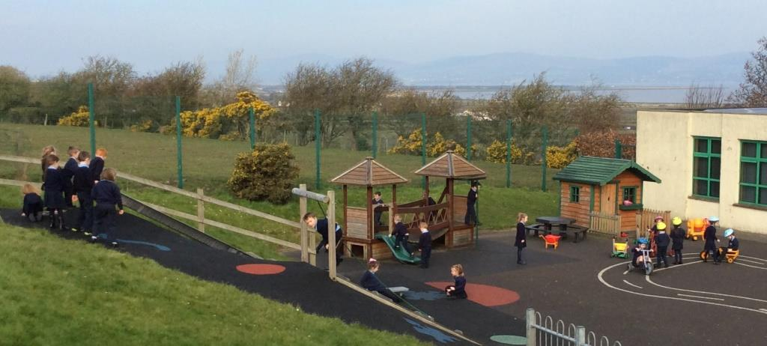

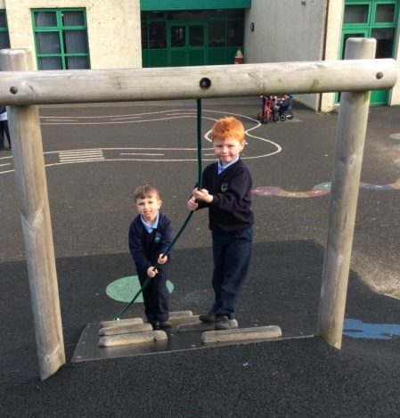

BOARD OF GOVERNORS

Representing EA Mr Ian Doherty ( Chairperson )

Representing Trustees Fr P Mullan, Mr G Nicholl, Mr F Curran, Mr J McGee

Representing DE Mrs R Parkhill

Representing Teachers Mr C O’Hare

Representing EA Mrs J Toner

Representing Parents Mr C O’Neill

Secretary Mrs A McGroarty
Principal Mrs A McGroarty
Vice Principal Mr C O’Hare
Teachers
P1 Mrs J Vowles-Downey Cook – in – charge Mrs A McCorriston
P2 Miss C McCartney Assistant Cooks Mrs E Symth
P3 Mrs R McKeever Mrs C Loughrey
P4A Mrs M McLaughlin Ms Mary Donnelly
P4B Mr S Conaghan Ms Georgina O’Kane
P5 Miss C Gallagher Ms Elizabeth Osbourne
P6 Mr C O’Hare Supervisors Mrs C Logue
P7 Mrs A O’Hare / Mrs G McKay Mrs C Higgenbotham
Caretaker Mrs T Loughery
Cleaner Mr S Armstrong
Secretary Mrs C Long

Classroom Assistants Mrs C Logue, Mrs C Higgenbotham, Miss R Costello
SCHOOL STAFF

ADMISSION CRITERIA

Admissions: 40 Enrolment: 279

Following the Department of Education recommendations all prospective parents/guardians should note that they will be required to submit verification documents as to their normal place of residence when applying to the school of their choice.

ADMISSIONS CRITERIA – YEAR 1
The Board of Governors of Faughanvale Primary School has determined that the following criteria shall be applied, in the event of the number of pupils applying for places in Year 1 being greater than the admissions number, in the order set down below. Children normally resident in Northern Ireland at the time of the proposed admission will be selected before children not resident in Northern Ireland.

- Children of compulsory school age of staff presently employed in the school.

- Children of compulsory school age who normally reside in the catchment area of the school, in the Parish of Faughanvale.

- Children of compulsory school age who normally reside in the village of Ballykelly for whom Faughanvale PS is their nearest Catholic Primary School.

- Children of compulsory school age who have a brother/sister/half-brother/half sister/foster brother/foster sister attending or have attended in the past.

- Preference will be given to children of compulsory school age with exceptional circumstances (medical, social or other problems) that necessitate admission to Faughanvale Primary School rather than any other primary school. The circumstances should be personal to the child and must be supported by the independent and appropriate documentation, providing evidence of the circumstances being described as being exceptional.

- Children whose after carer resides in the Parish of Faughanvale.

- Other pupils of compulsory school age – selection will be made by proximity to school by
recognised relevant bus routes.

The Board of Governors, including the Principal, will apply the criteria if necessary.

YEAR 1 ADMISSIONS – AFTER THE BEGINNING OF THE SCHOOL YEAR

Children who apply to enter the school during the academic year will be considered using the same criteria as for Year 1.

ADMISSIONS CRITERIA – YEARS 2-7

Pupils will be admitted for enrolment provided that:

The following Criteria will be applied in the order set down 1 – 3.

- The school will not exceed its enrolment number as determined by the Department of Education.

- In the opinion of the Board of Governors their admission would not prejudice the efficient use of the school’s resources.

- If over-subscribed on this criterion children will be selected on the basis of the following sub-

criteria applied in the order set down.

a) P2 children before P3, P3 before P4 etc

b) Shortest walking distance between home and school.

ADMISSIONS ARRANGEMENTS

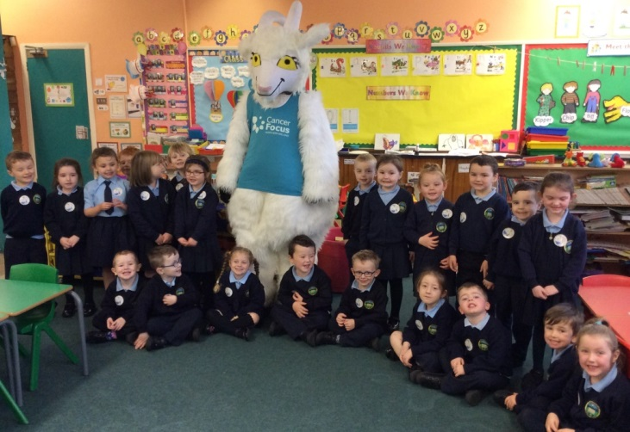

Children whose 4th birthday falls on or before 1st July 2018 are eligible to start school. These children are invited to visit the P1 classroom on a designated day in June of the year preceding their entry to school. In September they are then phased in, in smaller groups.
- We aim to provide quality experiences in all aspects of school life so as to
AIMS
enable our children to be happy, successful and keen to learn.

- We aim to help our children grow into young people who are fulfilled and able to make a positive contribution to society.

“They come this way only once, so we should litter their pathways with quality experiences”

- We value the strong sense of our Catholic faith and aim to educate our children in the context of a warm, welcoming Catholic ethos.

We value good behaviour in the classroom, the school environment and as representatives of our school, in other venues.

- We will help children to appreciate the need for good behaviour, its importance and its benefits for everyone.

- We aim to educate the whole child by presenting a total experience, which will enrich each according to their individual potential. In doing so we will foster the child’s intellectual, spiritual, physical, moral, social and cultural development, within the context of the Revised Northern Ireland Curriculum.

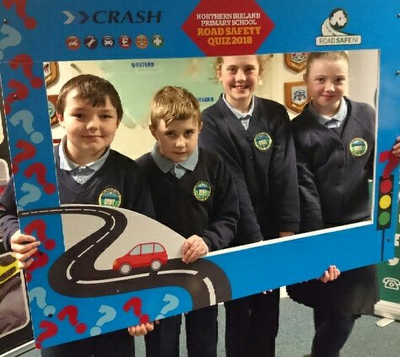
- We value, respect and believe that children should have a happy way of being together. Their self- respect should lead to a respect for the rights and needs of other children and adults from our own culture and community as well as other communities and cultures.

- We aim to help children prepare for life in a rapidly changing world and will develop learning skills which will prepare children for their future school and lives.

SCHOOL HOURS

The school day begins at 9.10am. Children should be in their classes by this time. Children will be supervised from 8.50am – 9.10am each morning by a teacher on duty.

There is supervised playtime for all children from 10.40 – 10.55am. The lunch break runs from 12.00pm – 1.00pm with 2 sittings for P1 – P4 and P5 – P7 respectively.

P1 & P2 finish at 2.00pm.
P3 – P7 finish at 3.00pm.

There is a return bus service at 8.45am and 3.00pm for children who live in Killywool and Ballykelly areas. There is also a return bus service for those who live in the Greysteel, Gortgar and Eglinton districts. The homeward journey starts at 2.00pm for P1 and P2 children and at 3.00pm for all other children

ATTENDANCE

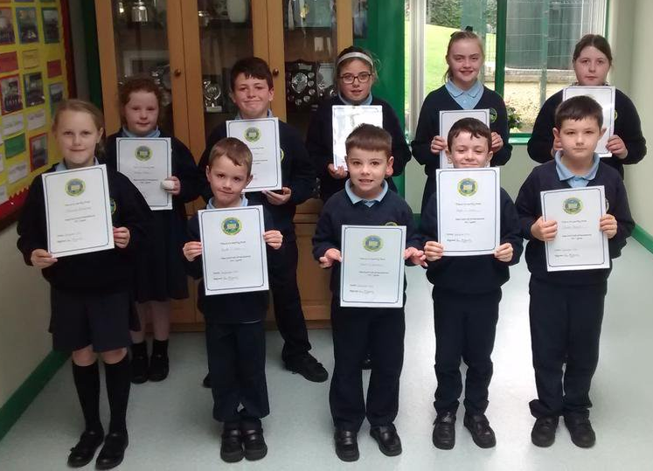
All children must attend for 190 days per year, which the law requires. This also includes the half days at Christmas, Easter and Summer Terms. There may from one year to the next, be a variation in the total number of days children can attend as the Department of Education may arrange a number of school development days. On these days staff are at work but children will have a holiday.

If for any reason your child is absent you
should send a note or telephone explaining the absence for our records. If your child has to leave school during school hours or has different arrangements for travel at home time, a note or telephone message is required.
CURRICULUM

This is the sum total of all we do in school. This includes the statutory Revised Northern Ireland Curriculum, which came into effect in September 2007. This is set by the Department of Education and determines what children should be taught at the

Foundation Stage – P1 & P2, Key Stage 1 – P3 & P4, Key Stage 2 – P5, P6, & P7.

Under the Revised Curriculum there are 7 Areas of Learning. This includes:

Language & Literacy
Mathematics & Numeracy
The Arts
The World Around Us
Personal Development & Mutual Understanding
P.E. and
R.E.

ASSESSMENT

The Revised Curriculum also means a revised way of assessing your child. Children from P4 – P7 are assessed using Computer Based Assessments in October. All year groups will also be assessed formally and informally throughout they year.

Our school strives to present children with lively and exciting experiences, which will enable them to work within the Revised Northern Ireland Curriculum, with enthusiasm and according to their abilities. Children’s ability and progression will be reported to parents in November at the Parent/Teacher meetings and in June with a written report. Parents may of course feel free to contact the school throughout the year if they wish to speak to their child’s teacher.
CHILDREN WITH SPECIAL NEEDS

Care is taken to match curricular provision with pupils’ needs and assessment is used to detect pupils with particular difficulties or special talents. When this arises, our Special Educational Needs Co-ordinator liaises with parents and class teachers, in accordance with the Code of Practice, to develop an appropriate programme of work. The school also works closely with the EA Psychology Service and various learning support agencies to ensure that each child benefits from the best educational opportunity. Faughanvale Primary School complies with the Special Educational Needs Disability Order (SENDO), which became legislation in September 2005.

PRIMARY 7 TRANSITION

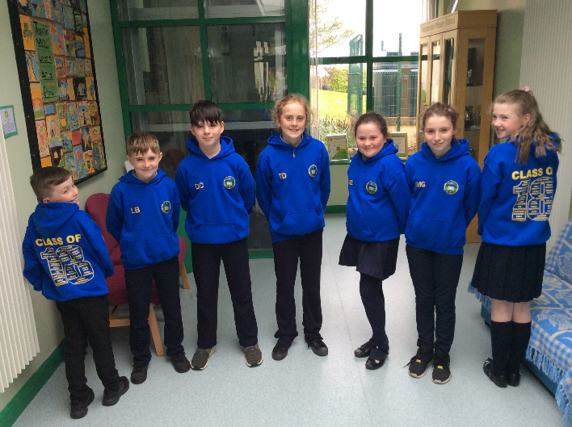
P7 children are visited by a number of local secondary and grammar schools. This affords them the opportunity to talk to the link teacher of these post-primary schools and to discuss and prepare for the transition the following year. The children and staff find this a very worthwhile experience and as a result the children are less apprehensive about changing to their post primary school. Primary Schools no longer operate a Transfer Test (11+) in November. The Department of Education has withdrawn such testing since November 2010. Parents who wish to send their children to a Grammar School must register with the post primary school of their choice and in November / December of their P7 year these children will be invited to that school to sit Papers in English and Maths. They will receive their results by post in February of their P7 year.

EXTENDED SCHOOLS

Our school has been selected as one of the schools to take part in the Extended Schools Programme. This means we have been offered an additional budget to cover the costs of a variety of schemes. Extended Schools provision is centred around an Outcomes Framework based on the theme of ‘Living in a Society which respects the rights of children and young people’.

THERE ARE 5 OUTCOMES:

Being Healthy Contributing Positively to Community & Society

Enjoying, Learning & Achieving Living in Safety and With Stability

Experiencing Economic & Environment Well-Being

We view working with our pupils, families and community as an essential element in raising the standard of pupils’ achievements. We aim to ensure that the activities we provide will help to strengthen families and communities through providing opportunities for life-long learning and personal development. Activities we will be involved in this year include:

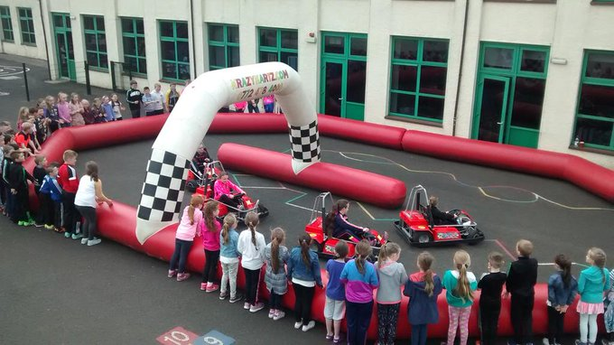
- Counselling
- Breakfast Club
- Homework Club
- Yoga programme
- Accelerated Reading
- Paired Reading Programme
- Summer Scheme
- Relax Kids
- 2-3 Club for P1 & P2

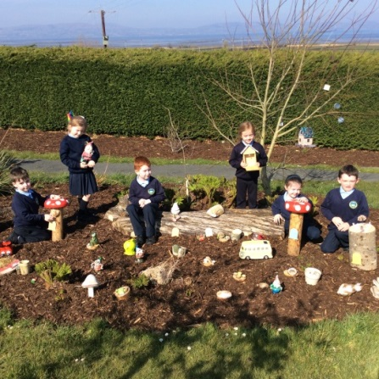
These activities are carried out mainly after school and ensure that all children from P1 – P7 can have an opportunity to take part in at least one, if not more activities.
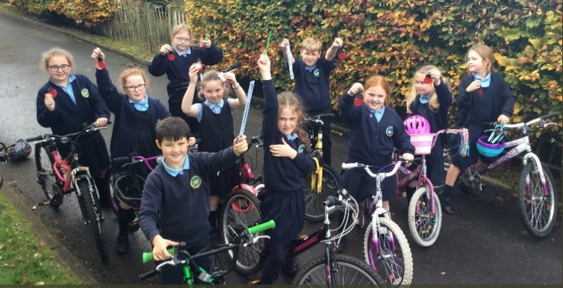

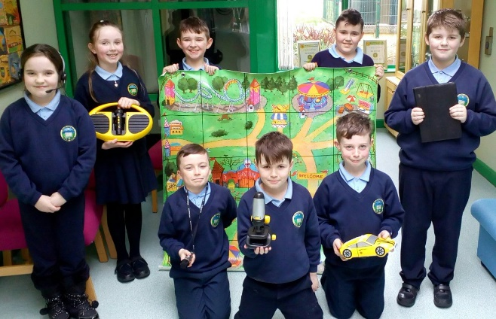
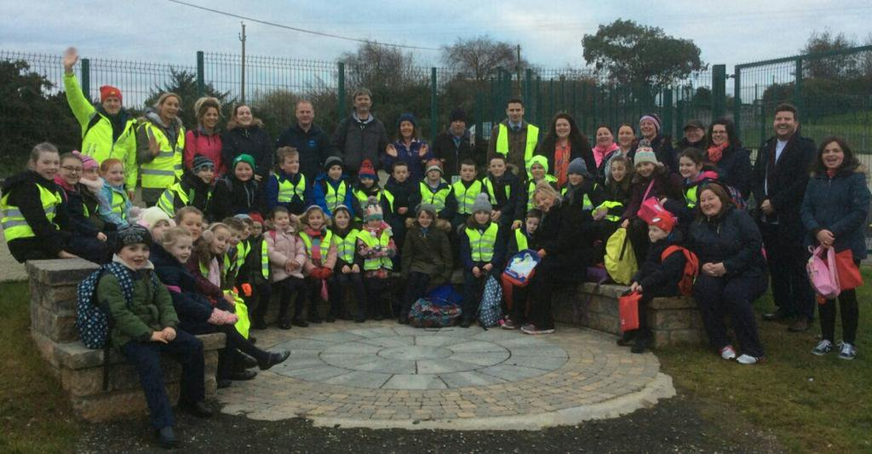

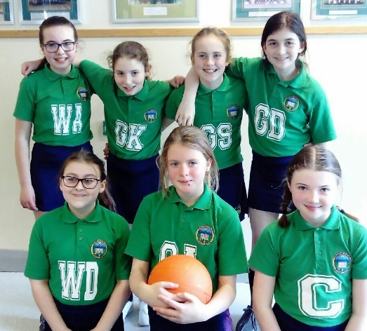
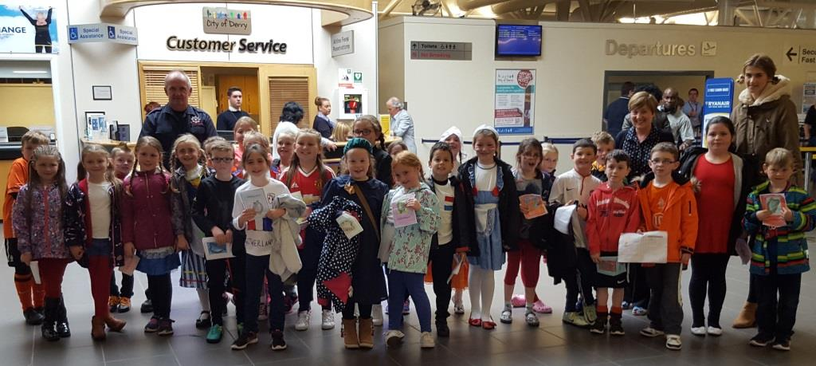

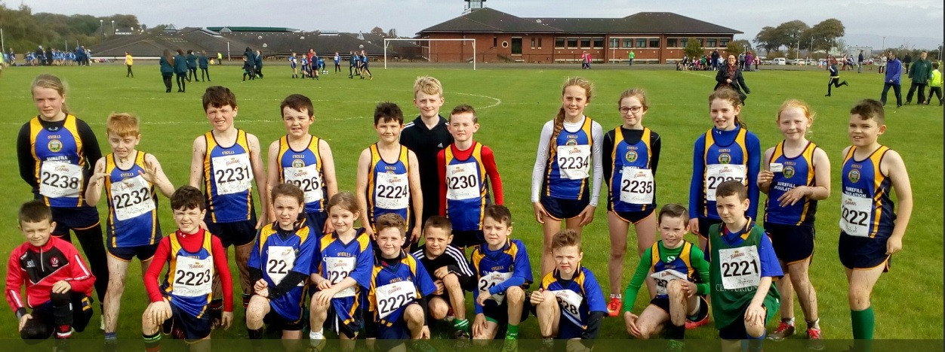

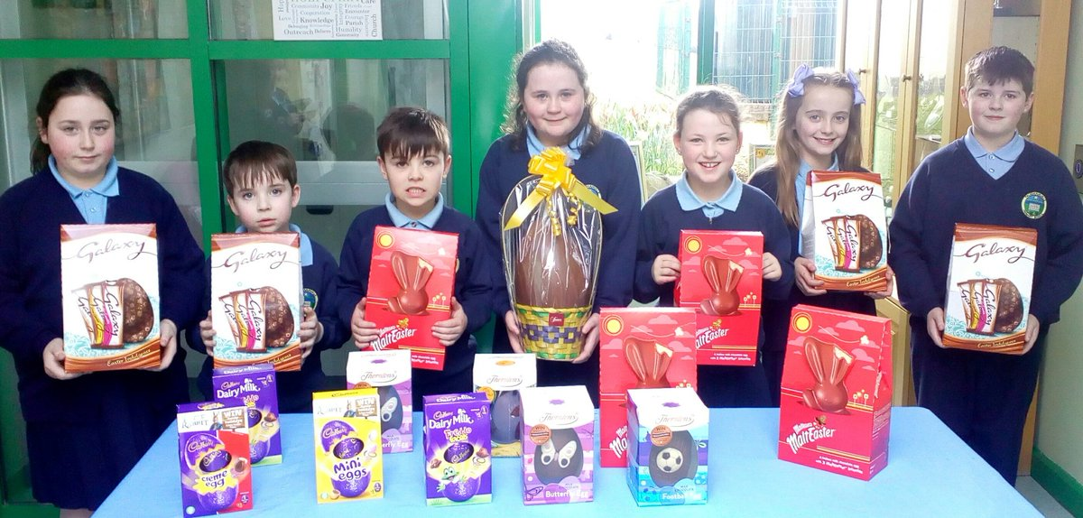
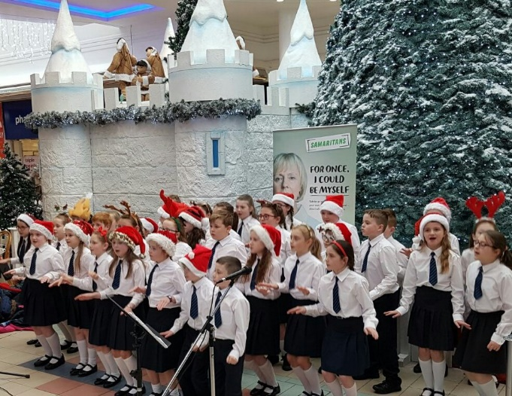

The purpose of homework is:
HOMEWORK

To reinforce learning and understanding of topics covered during the day

To encourage parental participation in their children’s learning.

Homework will be given to each child. During absences from school, homework will not be sent home unless the parent requests it. Only the parent knows if the child is well enough to undertake homework. Homework will be oral, written or both and will relate to work taking place in the classroom.

Types of homework that may be given include:

Literacy - practice in language development activities, particularly
reading and spelling.
Numeracy – work aimed at improving and reinforcing mathematical
skills.
Topic work – where pupils carry out inquiry-based activities. On such
occasions children may be asked to seek assistance from
parents, relations etc. in collecting information and/or
relevant resources material.
Religious Education – learning prayers associated with the Alive-O programme.

Pupils who have produced unsatisfactory work during the school day may be asked to amend/complete it at home.

Parents are encouraged to monitor and support their child during homework and ensure that set tasks are completed to a satisfactory standard. Parents should sign their children’s homework every night. It is important to take a real interest in the school and in your child’s schoolwork. Your child will reflect your own attitude towards education.

Parents are strongly encouraged to engage in shared reading and relevant talking and listening activities.

Educational research clearly shows that where a parent spends 10 – 15 minutes each night reading with their child, that child makes significantly greater progress in school than the child who does not receive this support.

Homework should not cause undue anxiety or stress. In the event of this happening, parents should contact the school.

PASTORAL CARE
Whilst academic progress is very important in the life of the child, there are also many other factors to take into consideration. It is recognised that the school has a role to play in the pastoral care of the pupils. Faughanvale Primary School is deeply committed to this aspect of pupil care. All staff work closely together to ensure the welfare of the children in the school. In addition, in matters relating to the pastoral care the Principal liases with parents, guardians and outside agencies.

Parents are urged to discuss any matters of concern with staff whenever they feel it is advisable. The Principal will also be pleased to see parents who wish to discuss any matters of concern. The school also has a fully trained Staff member who can provide Cruse Bereavement Counselling.
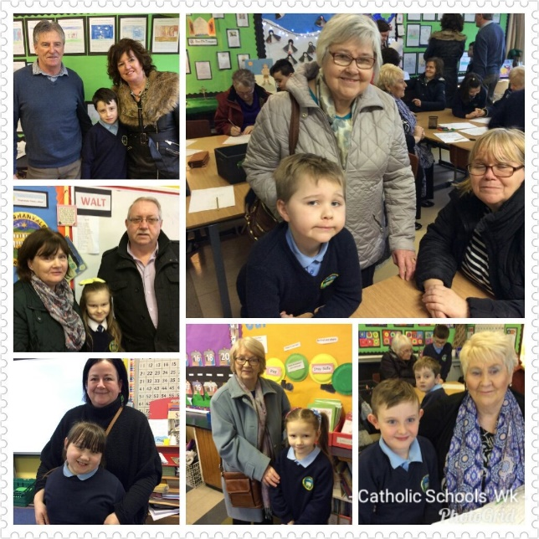

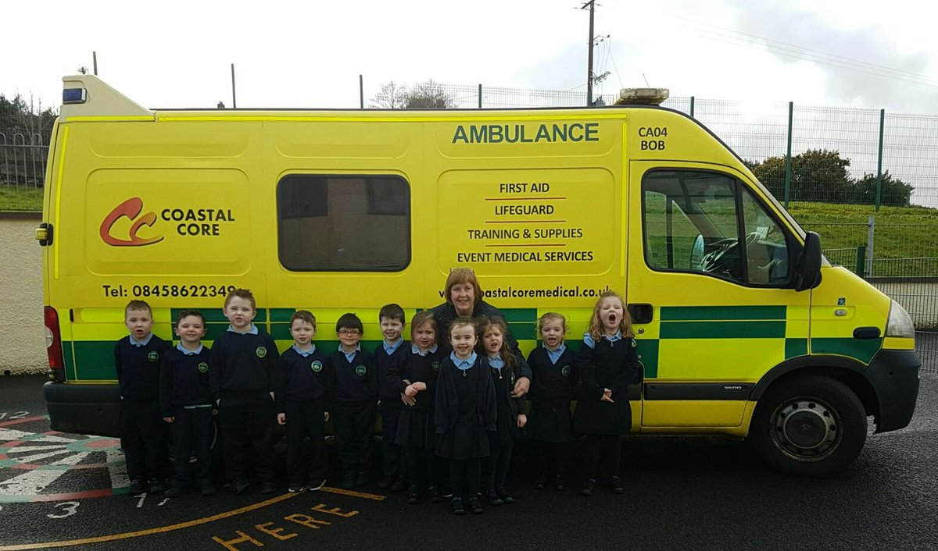

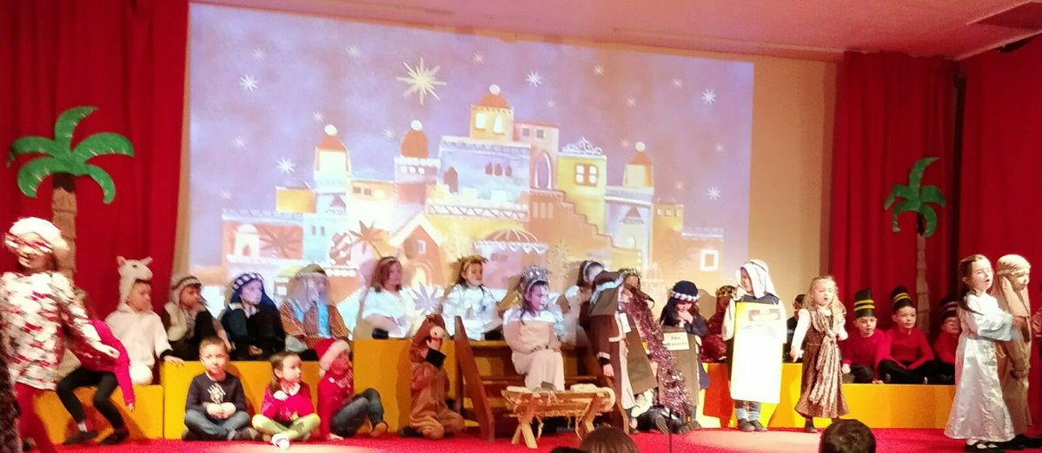

From time to time Parents may wish to raise concerns about issues which may be affecting their children’s well-being and happiness. We are a Listening School and our complaints Policy ensures that Parents can approach the school and air their concerns in the knowledge that they will be given a fair hearing. The Flow Chart below outlines the procedure carried out in our school when a complaint is made by a parent.
COMPLAINTS POLICY

COMPLAINTS PROCEDURE FLOW CHART (With timescale for responses)
Informal – Step 1

Comment / Complaint made to appropriate member of staff (verbally)
Informal – Step 2

Comment / Complaint made to Principal (verbally)

Formal – Step 3

Formal written comments / complaints made to Principal

Discuss the issues.
Implement any agreements.
No further action.

agreements
Implement any agreements
Appeals Process – Step 5

Written requests to Chairperson to have case heard by Appeals Sub-Committee of Board Of Governors

Formal – Step 4

Formal written comments / complaints made to Chairperson of Governors and referred to Governor’s Sub-Committee

Schedule Meeting
Discuss the issues
Implement any agreements
No further action.

Acknowledge receipt (within 10 working days)
Investigate the complaint.
Implement any agreement / changes
Confirm outcomes in writing (within 20 working days)
No further action

Acknowledge receipt (within 10 working days)
Investigate the issues / meet the complaint.
Implement any agreement / changes
Confirm outcomes in writing (within 25 working days)
No further action.

Acknowledge receipt (within 10 working days)
Meet the complaint ((30 working days)
Consider the issues.
Implement any agreements / changes
Confirm outcomes in writing (by the 40th working day)

CHILD PROTECTION
As an expression of our belief that a child should be happy, content, safe and self confident, we implement a Child Protection Programme. This offers pupils protection through a caring classroom environment and through programmes planned to develop the child’s confidence and self-esteem. The school is required by law to report any serious concerns regarding suspected abuse to appropriate agencies. Written procedures are in place and Mrs. Anne McGroarty is the designated teacher who deals with child protection matters. In her absence Mr Sean Conaghan will assist with these matters.

The Flow Chart below outlines the procedures carried out in our school when there is a concern about Child Protection.

Procedures for PARENTS WHO WISH TO RAISE A CHILD PROTECTION CONCERN

I have a concern about my / a child’s safety

I can talk to the class / form teacher

If I am still concerned, I can talk to the Designated / Deputy Designated Teacher for Child Protection

Mrs McGroarty

Mr Conaghan

If I am still concerned, I can talk / write to the Chairperson of the Board of Governors

If I am still concerned I can contact the NI Public Services Ombudsman
Tel: 0800 343 424

At any time a parent can talk to a social worker at the Gateway Team (Western Trust) Tel: 02871314090
Or the
PSNI at Central Referral Unit
Tel: 999 (Emergency) or 101 (Non-Urgent)

Procedure where the school has concerns, or has been given information about possible abuse by someone other than a member of staff.

Member of staff completes the Note of Concern on what has been observed or shared and must ACT PROMPTLY.
Source of concern is notified that the school will follow up appropriately on the issues raised.

Staff member discusses concerns with the Designated Teacher or Deputy Designated Teacher in her absence and provides note of concern.

Designated Teacher should consult with other relevant staff before deciding upon action to be taken, always taking care to avoid undue delay. If required advice may be sought from a CPSS officer.

Child Protection referral is not required
School may consider other options including monitoring the situation within an agreed timescale; signposting or referring the child/parent/carers to appropriate support services such as the Children’s Services Gateway Team or local Family Support Hub with parental consent, and child/young person’s consent (where appropriate).
Child Protection referral is required
Designated Teacher seeks consent of the parent/carer and/or the child (if they are competent to give this) unless this would place the child at risk of significant harm then telephones the Children’s Services Gateway Team and/or the PSNI if a child is at immediate risk. He/she submits a completed UNOCINI referral form within 24 hours

Where appropriate the source of the concern will be informed as to the action taken. The Designated Teacher will maintain a written record of all decisions and actions taken and ensure that this record is appropriately and securely stored.

Designated Teacher clarifies/discusses concern with child/ parent/carers and decides if a child protection referral is or is not required.

ANTI-BULLYING
We are committed to providing a caring, friendly and safe environment for all
our pupils so that they can learn in a relaxed and secure atmosphere.

Bullying of any kind is unacceptable at our school. Respect for each other will be promoted through the caring ethos that exists in the school and through the delivery of the curriculum. If bullying does occur, procedures are in place to take appropriate action regarding the behaviour and effects of the children involved.

We welcome parents’ intervention, through the proper channels but would ask that when discussing problems to do so out of ‘earshot’ of the child.

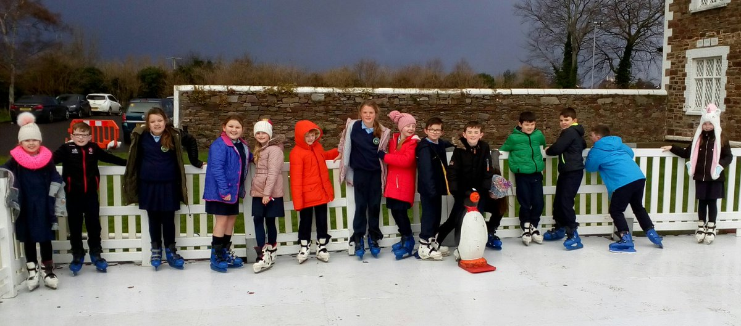

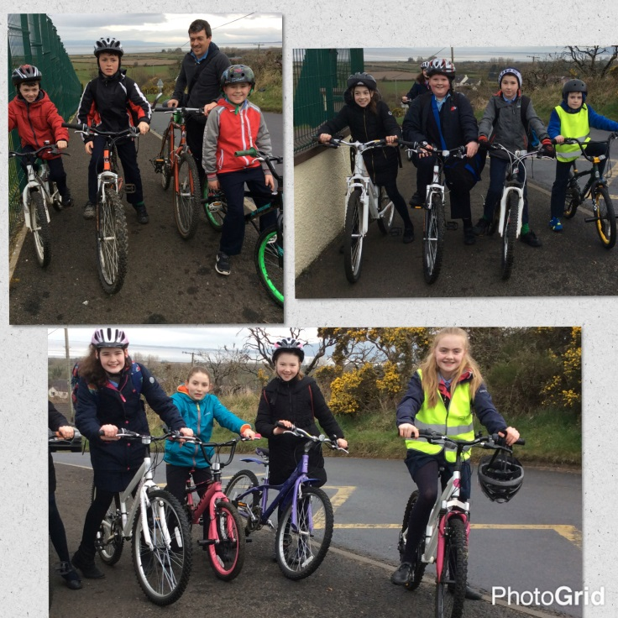
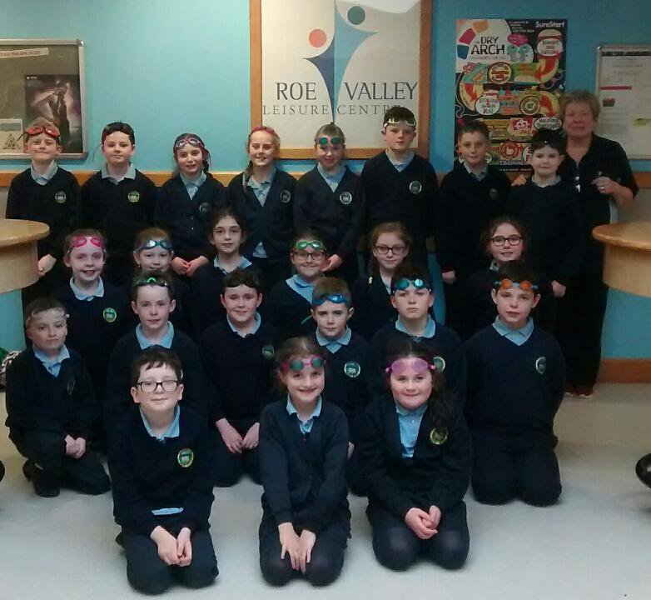

We recognise our responsibility under current health and safety requirements to endeavour, in as far as is reasonable and practical, to secure the health, safety and welfare of pupils, staff and visitors.
HEALTH AND SAFETY

Our school is a Health Promoting School. Up until May 2009 we were recipients of the ‘Gold’ Award for Health Promoting School. This initiative, whilst no longer running still remains a central theme in the standards of health and well-being we set for our children.

We value our pupils well-being and daily encourage healthy attitudes to eating, exercise, rest and hygiene, personally and environmentally. Therefore we actively encourage healthy breaks and lunches, cleanliness, particularly in sport and games, recycling, conservation of heat and light and respect for ourselves, each other and the environment. We have consistently achieved the Healthy Munch Box Award for the high and consistent standards of healthy packed lunches.

We have won the prestigious Green Flag Award four times. We are the first school to have achieved so many Green Flags in the Limavady Council Area in recognition of our efforts to increase awareness of environmental issues. Our focus so far has been to create a garden to encourage birds and insects to visit, to monitoring our consumption of oil and electricity and to look at wider environmental issues.

We are also aware of how lucky we are to live where we do and we promote awareness of how others in the world are less fortunate. Our children, with the help of their parents raise money for various charities. These include, St. Vincent de Paul, Childline, Marie Curie, Children in Crossfire and Trocaire. We also collected gifts for the Road of Hope Christmas Shoe Box Appeal.
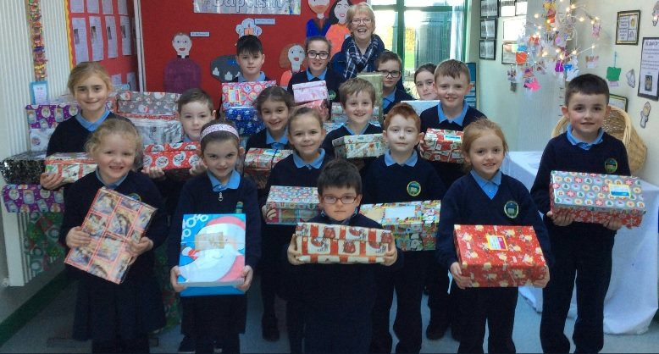

In accordance with the ethos of the school and with regard to the Programme of Study we aim to provide knowledge, development skills and attitudes to promote a positive lifestyle approach with emphasis being placed on the personal responsibility of the individual in making decisions and informed health choices. Through our school policy we work with parents and outside agencies addressing the issue of drug awareness in a positive way that develops our children’s knowledge and understanding of the use and misuse, risks and effects of drugs and other potentially harmful substances. In order to deliver this we:
DRUGS POLICY
- Raise drug awareness of the staff (teacher and ancillary) /parents
- Designate a member of staff as having overall responsibility for drug
issues – Mrs. Anne McGroarty.
- Establish procedures for handling cases of suspected drug misuse on
the premises.
- Provide a safe school environment – secure school premises – provide
safe storage for solvents etc.
- Develop drugs education programme and teaching approaches suitable
for each age group.
SCHOOL RULES / POSITIVE BEHAVIOUR POLICY

The aim of Faughanvale Primary School is to enable pupils to achieve their physical, intellectual, social and spiritual potential and to improve their self-knowledge and self-esteem within the school environment. In keeping with the tradition and ethos of the school, high standards of personal behaviour are expected from each pupil. This is outlined in our Positive Behaviour Policy.

Rewards and Consequences

Rewards – the positive side of discipline. The emphasis is on the positive approach of encouragement and praise involving incentives and inducements. There are a variety of ways of recognising achievements which the school uses and these include: teacher praise and approval, star charts, privileges, good conduct reports, opportunities for greater responsibilities and Principal’s approval.

Consequences – the aim is to replace the child’s inappropriate behaviour with something more acceptable. To help them reflect on the impact of their actions and consider an alternative response. Poor choices of behaviour will be followed up and there will be some form of restitution. Consequences may include detention at break-time/dinner time, removal of privileges and report to Principal.

School rules are an extension of the disciplinary framework of the home and
HOME / SCHOOL CONTACT
the school seeks parents’ co-operation in implementing them.
The teaching staff actively encourages parental contacts with the school. The
school has established a record of each pupil on a safe and secure computer
system and parents are asked to fill in a form giving details of their children’s
date of birth, address, medical information, meal/travel arrangements and
names and telephone numbers of 3 contact persons in case of sickness.

We issue a Weekly Newsletter each Thursday. Parents can opt to receive this
in paper or electronic form. The electronic form can be accessed via the
Schools’ website or parents can have it emailed to them.

Please inform the office if telephone numbers, addresses or contact persons
change.

We also have a school website which keeps parents informed about the life of our school. To access this you can go to www.faughanvaleps.co.uk.
The school’s Twitter account @FaughanvaleS is created to share information and to celebrate with parents and friends of Faughanvale Primary School.

Our school app (Schools NI) helps keep parents up to date with any changes to the expected timetable or to facilitate contact with them in the case of an emergency.

LINKS WITH THE COMMUNITY

We maintain close links with other primary schools and local secondary schools. This link with our secondary schools ensures that our children’s transition takes place as smoothly as possible. We provide work experience and training opportunities for students from the secondary sector, Universities and Colleges of Education and Job Link.

During the year we welcome various members of the community and outside agencies into the school – educational psychologist, dentist, nurse, doctor, priests, peripatetic music teacher, outreach teachers, fire service, police service and drugs education support from WELB and Hope NW and of course our parents. We also value the visits our parents and grandparents make when they visit classes to support the children’s learning.

PARENTAL INVOLVEMENT
Parental involvement in the school is actively encouraged and highly valued. We believe that the support of parents is essential in working with the school for the child’s benefit. Parents are their children’s first educators and we encourage a positive parent/school partnership both formally and informally. Involvement can be formal through Parent/Teacher meetings, P1 Induction Programme, Paired Reading Programme, Parental Involvement in Numeracy, general information sessions and year group meetings. Informal meetings are also encouraged through parents sharing their skills or expertise to support our children in the classroom, at sports, in school concerts, educational visits or on any other occasion when our children are participating in a school related event.

We also have a very dedicated and active Friends and Parents Association. They have been instrumental in fund raising for much needed resources which any school’s limited budget cannot normally raise. As well as raising funds this Association has ensured that everyone involved has fun and this has helped forge links between school and home and the community. Successful events to date include Fashion Shows, Fun Day, Night at the Races, Christmas Bazaar, Christmas Fayre, a Dinner Dance, Jigs & Reels Evening and Movie Nights. Anyone who is interested is welcome to join the Association and help strengthen links with our school and our local community. Contact the school if you are interested or make yourself known on the Induction Day.

SCHOOL UNIFORM
Every child is expected to wear the following uniform –
Girls with long hair should tie it back. We encourage all parents to adopt a sensible attitude towards styling, colouring or dyeing of their children’s hair regardless of gender.
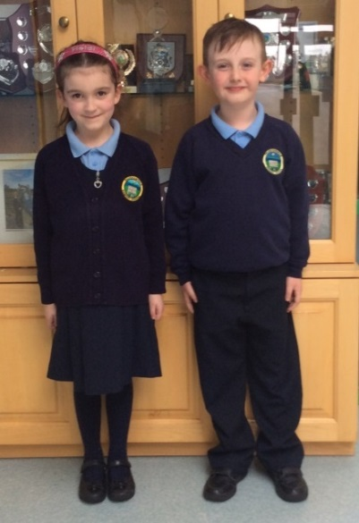
Boys:
Navy trousers
Light Blue Polo Shirt with school crest
Navy V – necked Pullover with school crest
Navy fleece with school crest.

Girls:
Navy Skirt / Pinafore, navy socks / tights
Light Blue Polo Shirt with school crest.
Navy V – necked Pullover / Cardigan with school crest.
Navy fleece with school crest.
Light blue chequered dress in warm weather.

In order to ensure that children do not mislay any articles of clothing, it is imperative that ALL outer layers of uniform are labelled with the child’s name.

JEWELLERY
Children are discouraged from wearing jewellery to school because of the safety factor. If children have pierced ears then they should wear only studs as hooped earrings etc may result in accidents. Children, who are wearing inappropriate jewellery, will at the class teacher’s discretion, be required to remove such items if they believe them to constitute a safety hazard.

P.E. KIT
Children from P5 upwards will bring suitable T-shirt, shorts/jogging bottoms and appropriate footwear and outdoor wear on the days they have P.E. or after school games.

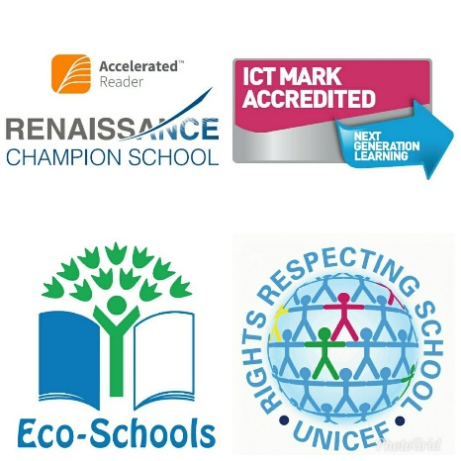
SCHOOL ACHIEVEMENTS

Our school has a rich heritage in the use of ICT. Our children are very skilled in using a wide range of information and communication technology (ICT) devices and software to extend and express their learning across the curriculum. In recognition of our achievements and commitment to using technology to improve our overall effectiveness and efficiency, our school was awarded the Naace ICT Mark in 2015

At Faughanvale Primary School, we believe in putting children’s rights at the heart of our school. The Unicef Rights Respecting Schools Award has helped develop our pupils’ acceptance of difference and diversity, and provided them with a strong moral compass.

We are very proud to have been awarded 4 Green Flags and permanent Eco status. ECO practices are now firmly embedded in our school ethos with our pupils working on issues involving: Litter, Waste, Energy, Water, Health and Wellbeing, Transport and Improving our School Grounds.

Reading transports curious minds to wondrous realms of the imagination. It determines success not only in the classroom, but in life. At Faughanvale Primary School our pupils are reaping the rewards fostered by a love of reading. Accelerated Reader has played an integral role in helping strengthen our children’s love of reading plus raise school standards in Literacy. We are recognised as an Accelerated Reader Champion School for our exemplary practices.
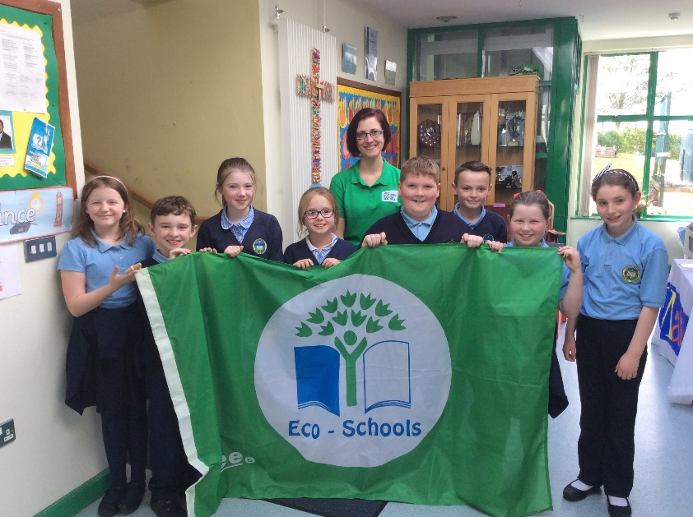

SHARED EDUCATION

At Faughanvale Primary School we have completed our first year of the Shared Education Programme with Ballykelly Primary School. The Department of Education for Northern Ireland is committed to developing partnerships between local schools in order to improve standards in attainment, increase the skills of staff, enhance resources for schools, as well as develop friendships across the community. We are delighted to be partnered with Ballykelly Primary School and have enjoyed shared experiences in both partner schools as well as visits to Magilligan Field Centre and Carrowmena Activity Centre. We ended the year with a celebration event for parents of all of the children involved, which was a great platform to showcase everything we have achieved this year. We look forward to continuing to develop these links with our partner school throughout the coming years.
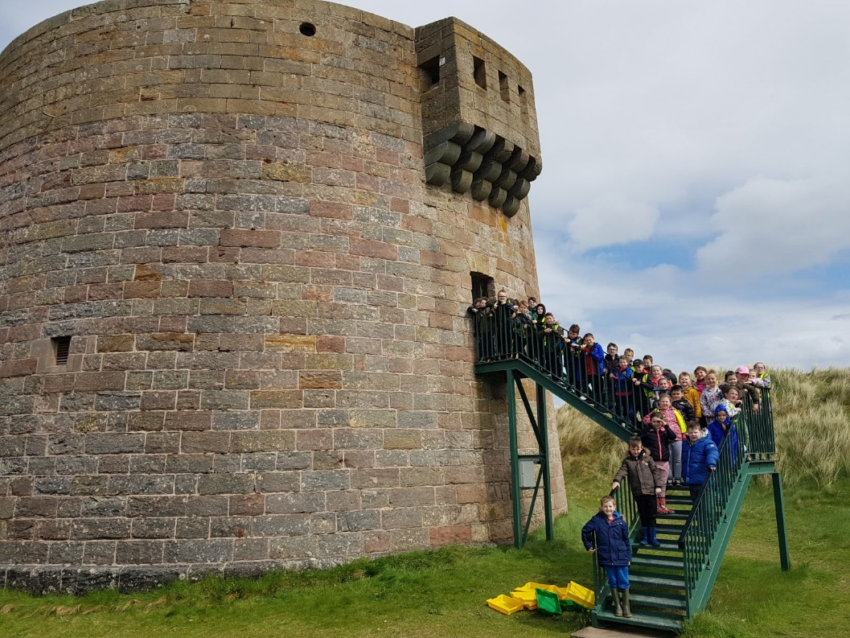

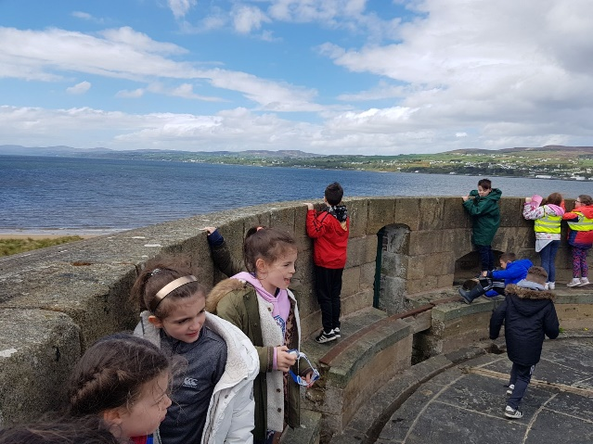
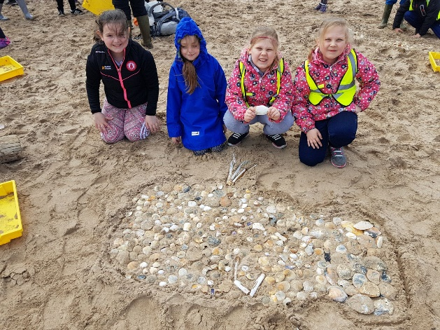

ARRANGEMENTS FOR PARENTS OF PROSPECTIVE PUPILS TO VISIT THE SCHOOL

Parents of prospective Primary One children are invited to the school in the term previous to admission for information sessions and workshops.

Enrolment forms may be obtained from the School Secretary in December or January prior to the children’s admission to P1 in the following September.

