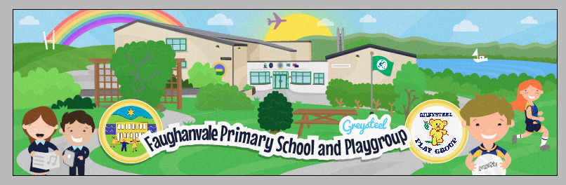

Dear Parents / Guardians
I welcome this opportunity to introduce Faughanvale Primary School to you as you consider the important decision of which primary school you wish your child to attend in September 2019.
Faughanvale Primary School is rightly proud of its place in the heart of its community. This brochure only provides a snapshot of life in our school. If you wish to find out more about us before you choose a primary school for your child, we would be delighted to welcome you to visit us so you can see why we are so proud of our children and our school!
In September 2019, Greysteel Playgroup will be moving to Faughanvale PS. We have always enjoyed close links with our local Playgroup and as we prepare to welcome them to our school, we look forward to forging even stronger connections with them in the future. An exciting time for all of us in September 2019!
Yours sincerely,
Anne McGroarty
Principal.

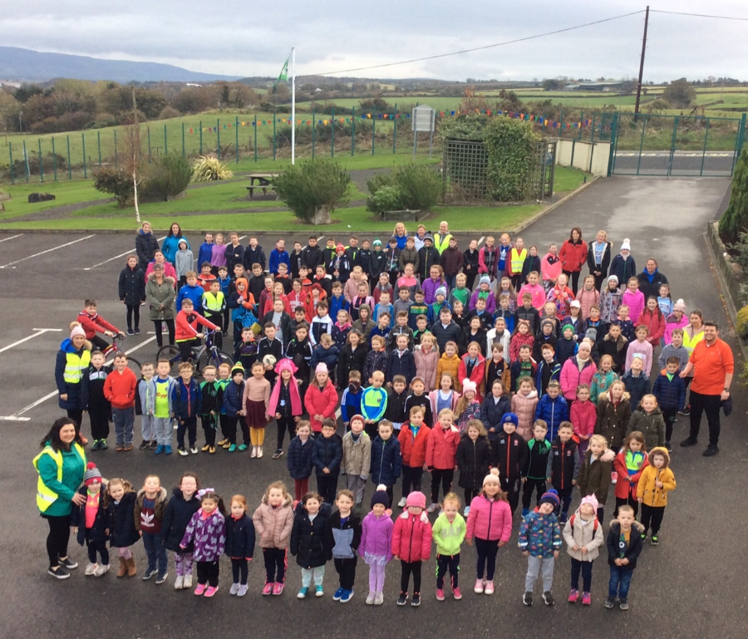

Faughanvale Primary School
@FaughanvaleS
Tel: 02871810529

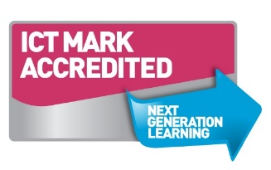
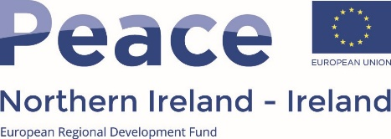

Faughanvale Primary school has a proud history of educating young people in our parish since before records were kept in the 1860s. When originally established it was a two roomed building located on the Dunlade Road and serving the needs of the mainly Catholic population of the area. Today we still pride ourselves on our rich Catholic heritage and as such we educate children of all faiths and traditions in a warm, caring and inclusive atmosphere, respecting each other’s differences and enjoying mutual respect.
Our Wonderful School

Our present school building, which is on the Vale Road, is well sign posted from the Clooney Road in Greysteel. It enjoys a prestigious location overlooking the beautiful Lough Foyle basin and the hills of Inishowen. All classrooms are well resourced to modern standards including Interactive Whiteboards, computers and i-pads. In addition, we have a Computer Room which is accessed by all classes in the school. In the spacious Assembly Hall pupils can enjoy PE. School productions are held annually there and this offers all pupils from P1 to P7 opportunities to develop their acting and singing talents. School meals are cooked in the modern kitchen on the premises and all children sit together for lunches or dinner in the Assembly Hall.
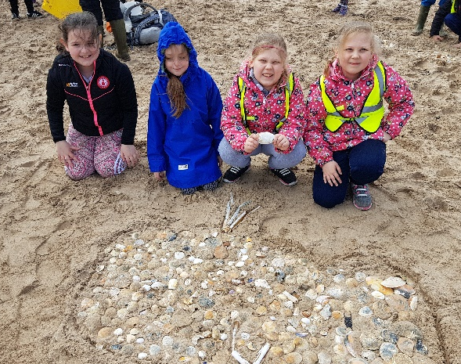
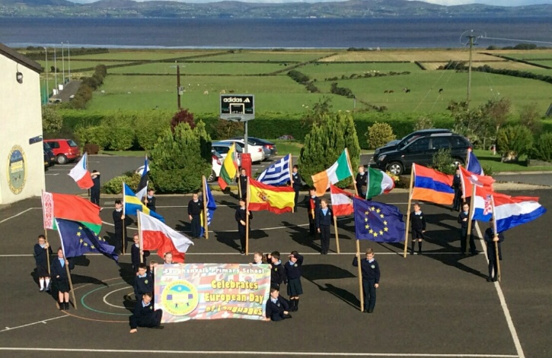

The school provides additional Literacy and Numeracy learning opportunities and for some children through Booster Support Groups. We also employ a Speech and Language Specialist to support learning in P1 and P2. Through our Extended Schools Funding we employ the services of North West Counselling.

To facilitate working parents, we provide a Breakfast Club each morning form 8.00am and offer additional extended learning activities up to 5.45pm. Pupils from P1 to P7 enjoy a wide range of innovative after school activities, including sport, choir, art and craft, gardening, modern languages, yoga and piano. The success of the Choir, Cross Country, Gaelic and Netball teams over recent years has been a delightful bonus for all associated with Faughanvale Primary School.

We have recently upgraded our pond and wild-life area and continue to listen to the children’s views as to what they would like to do to make optimum use of the school grounds, both for education and play.

Children travel to school by a variety of means. Local children walk or cycle. Translink provides a free bus service to those who live beyond a 2-mile radius from the school and for whom Faughanvale PS is their nearest Catholic school. This includes Killywool, Coolagh, Carrichue, Walworth and Ballykelly. North Coast Community Transport provides a daily return service from Eglinton, Greysteel and surrounding areas.
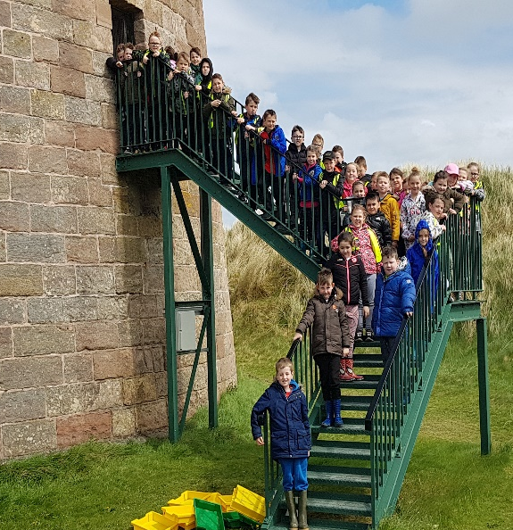
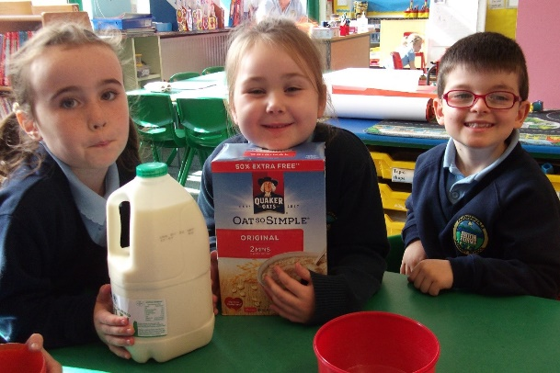

Here at Faughanvale we pride ourselves in delivering a well-planned Early Years Education. In Primary one, our well-resourced play activities develop a child’s imagination and creativity through experimental play, making and doing.
Fun and Learning in P1
Our class teaching takes an integrated, topic approach, where links are made throughout the subjects. We enjoy a wide range of visitors to our class, throughout our Thematic Units. A Speech and Language Therapist works with Foundation stage children, weekly, enhancing their listening skills and language development.
We benefit greatly from our small class sizes and teachers and children respect and encourage one another in the caring, supportive environment we have created.
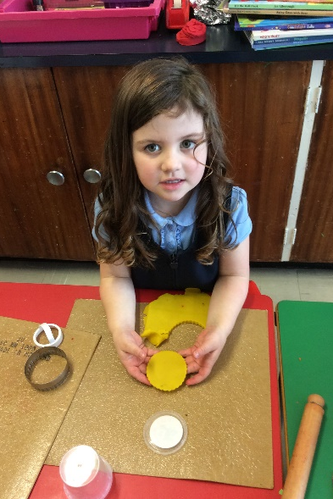
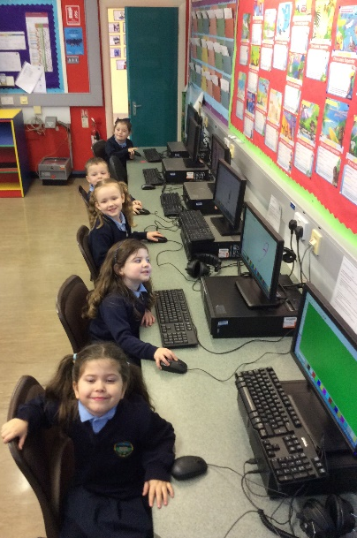
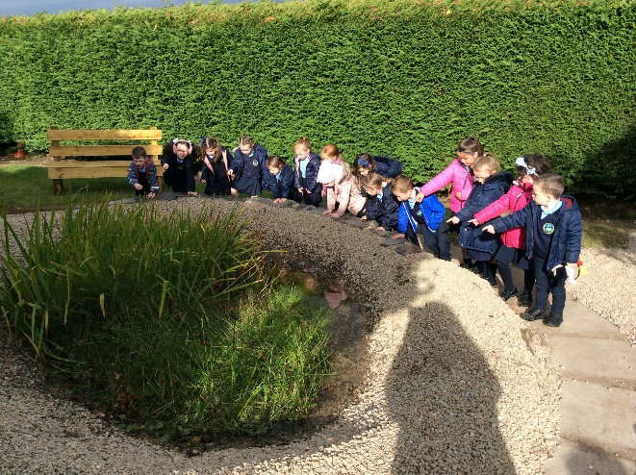
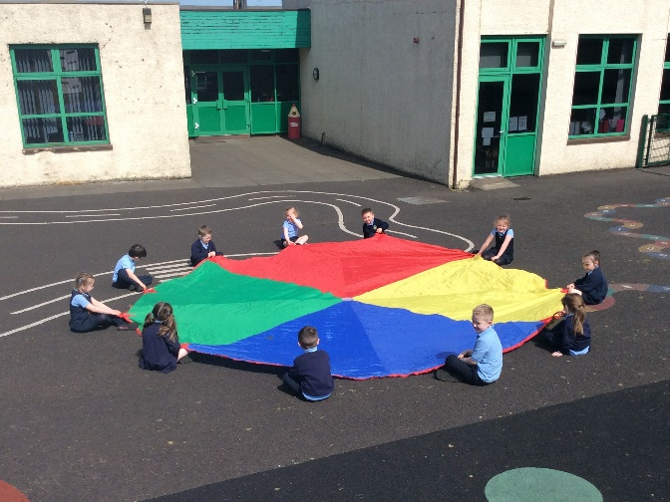
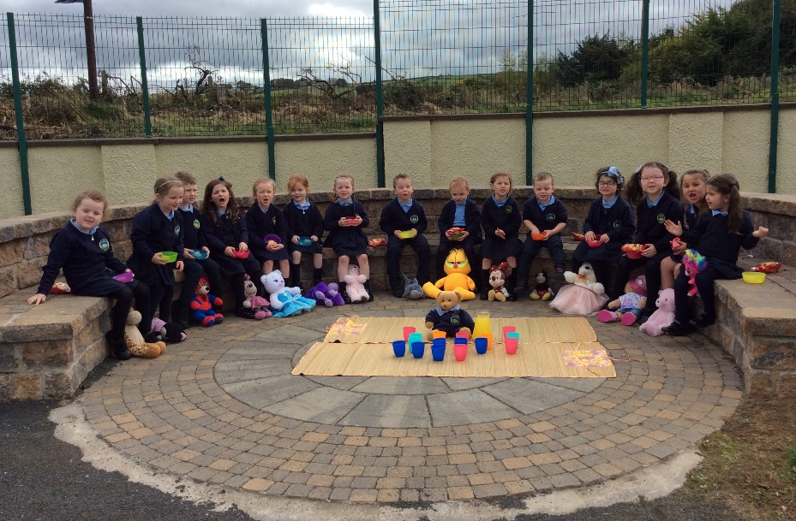
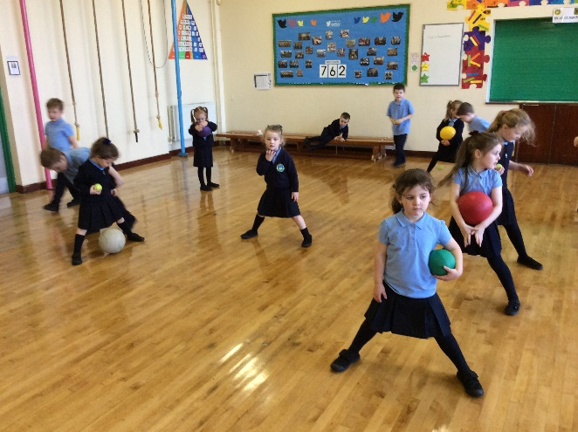
We enjoy a broad and balanced PE curriculum ranging from Gymnastics, Games and Athletics; covering the fundamental skills.

Outdoors for our nature
walk, visiting the school pond.

Enjoying an end of topic celebration with a Teddy bear’s picnic.

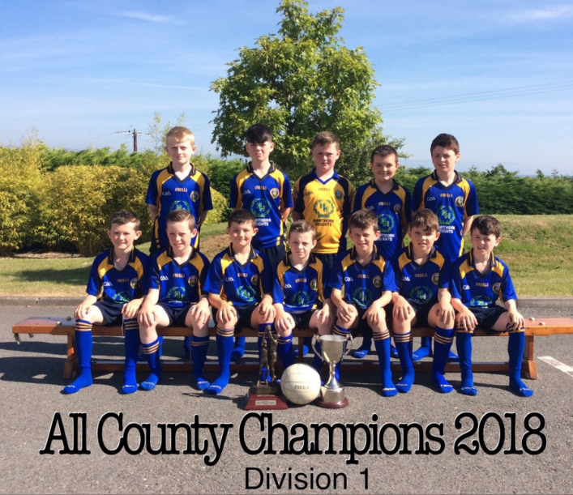
Gaelic Football
Our school has a very proud history of Gaelic Football. We place a major emphasis on enjoyment and encourage all of our pupils to participate in our national sport. We play competitively in the North West and All County Football Championship. In recent years our teams have enjoyed unrivalled success, culminating in the highest accolade of Division 1 All County Football Champions 2018!

Sporting Life

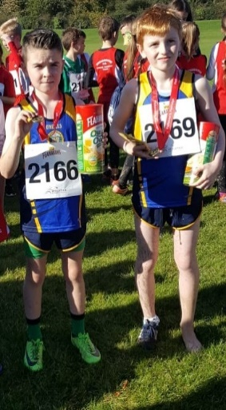
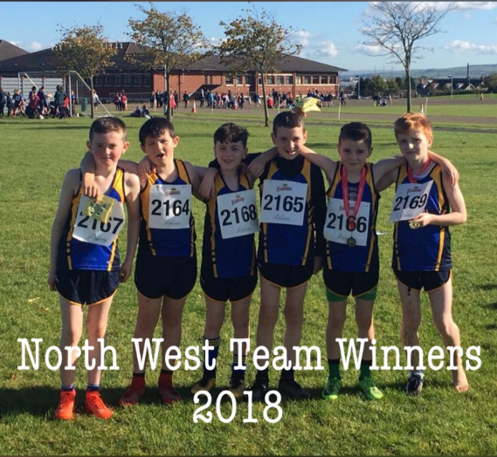
Cross Country
Our school participates annually in the Flahavan’s Primary School Cross Country League. We have a successful history to date, with an Northern Ireland individual winner in 2017 and team qualification for the N.I. Finals in 2018. This year we are in contention to reach the N.I. Finals with members of our boys’ team finishing 1st, 3rd and 5th in the opening round at Thornhill College.

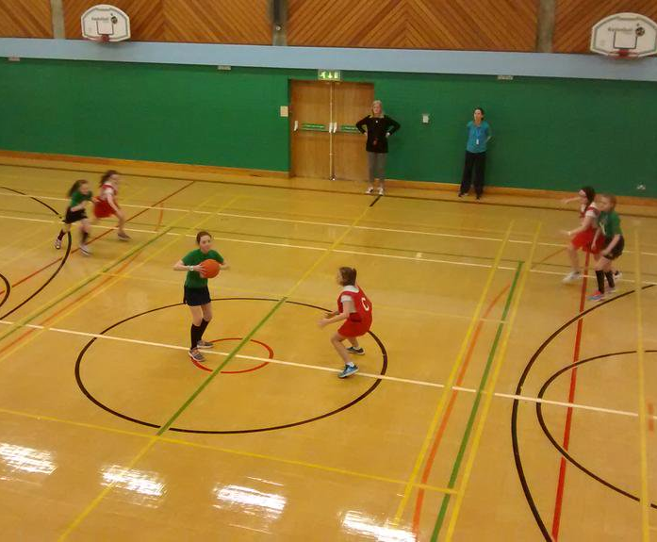
Netball
Our school takes part in the North West Derry Netball league every year. The children participate in a number of tournaments in the local area hoping to qualify in the Northern Ireland finals as we did in 2016! The girls display great teamwork whilst having fun.

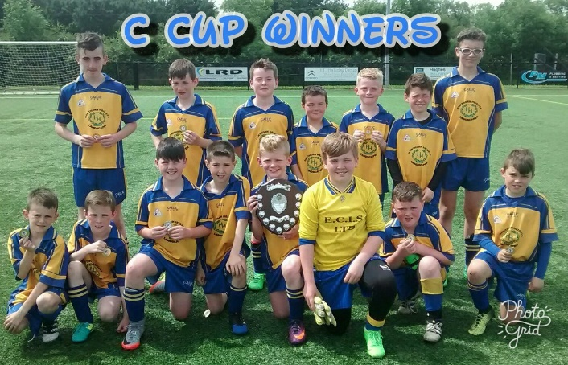

Football
Our pupils participate in the local Primary School Football League and Championship. Both boys and girls make up our team and despite being relative newcomers to the Football scene, we have made an immediate impact, securing the Football Championship title in 2016 – 2017!

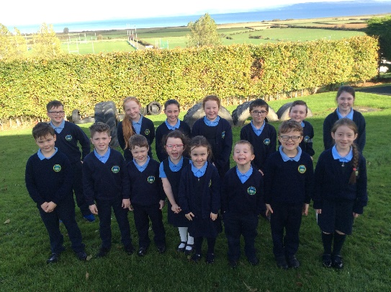
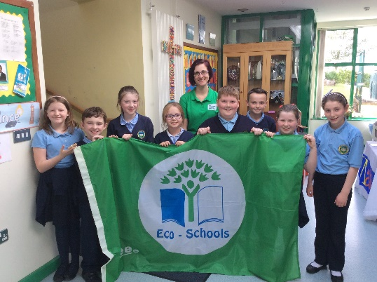
The school continues to drive standards of excellence both academically and vocationally. The well established Accelerated Reader Programme has seen a huge increase in the level and standard of reading throughout P4 to P7. Achievement of the ICT Mark has helped to ensure that children are well placed to interact with confidence in a digital world. We have achieved the Rights Respecting School Award and each class has created their own Charter to guide their conduct and relationships with others. The hard working School Council and Eco Committee have ensured that children are educated to take care of each other and the world around them. We are proud of our entire school community for having successfully been awarded 5 Eco Flags for attention to local and global issues. Through Peace IV Funding children enjoy Shared Education experiences and trips with neighbouring schools.

Achievements

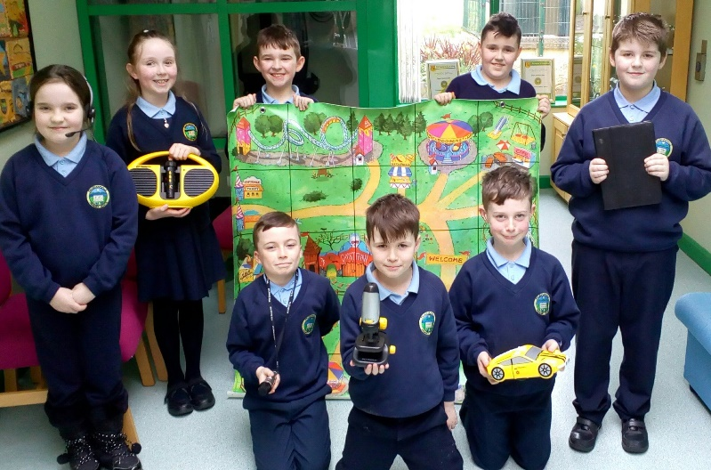

UICT plays an integral part of our school’s learning and teaching. Our pupils are highly competent in a range of innovative ICT practises. Activities such as Green Screening, Probot and Beebot Obstacles Courses, Stop-Motion Animations, QR Codes, Maths Trails, Radio Podcasting and Video Conferencing are just some of the advanced technological practices our pupils are exposed to. Our Key Stage 2 Digital Leaders facilitate the smooth day to day running of UICT. Our success in UICT has been rewarded with the highest honour of the prestigious ICT Mark.

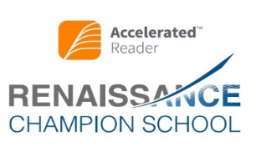
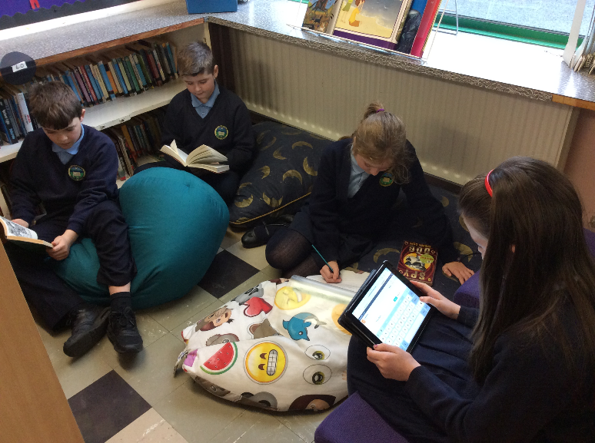

In 2016, we received the Renaissance Champion School award for our continued excellence practice in Accelerated Reader. A very definite reading culture has been developed within the school thanks mainly to the integration of the Accelerated Reader programme.

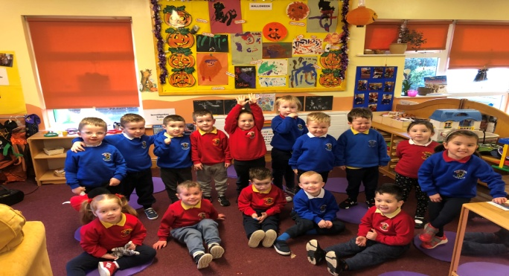
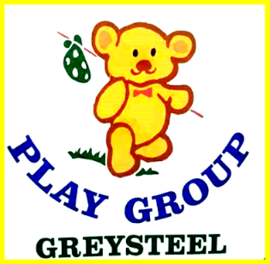
Est’d
1980

Morning Session
Tel: 71811355 9am – 12pm
Email:greysteelplaygroup@gmail.com Monday – Friday

Is your child due to start pre-school in September 2019?
We have funded places available for children turning 4
between 2nd July 2019 and 1st July 2020
“A friendly, caring atmosphere permeates the playgroup and the working relationships at all levels are excellent”
“The quality of pastoral care is outstanding”
“Excellent quality”

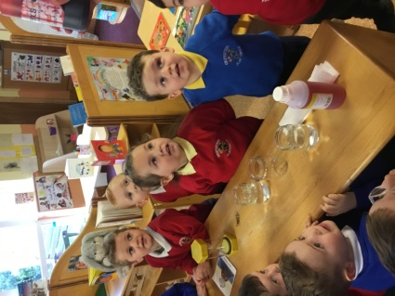
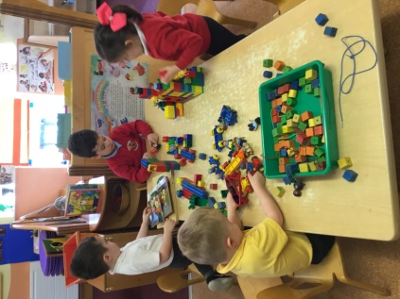

In 2015, we received an OUTSTANDING grade from the Department of Education
We are registered with the Western Health & Social Care Trust
Our staff are fully qualified, caring and experienced

We welcome children from all cultures and traditions
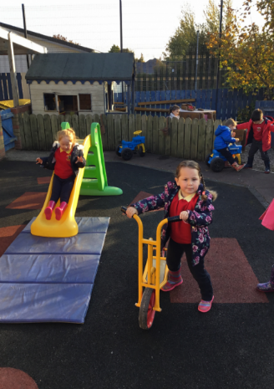
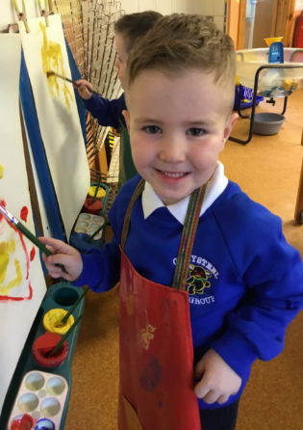
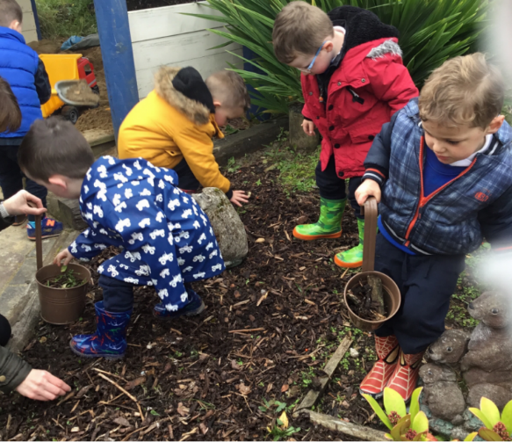
We are committed to the development of ‘The Arts’ curriculum which encompasses Music, Art and Drama. We ensure that our children have a full and rich experience in all strands of these subject areas.
The Arts
Our school choir performs at annual Liturgical services and secular events throughout the school year. We also take part in a variety of singing competitions and events both locally and nationally, where we have enjoyed many successes. This includes: the Fr Adrian Memorial Competition, Feis Doire Cholmcille and the International Choral Festival. To date we have produced 2 CDs which have captured the children’s eclectic tastes in music and provided them with fond memories to cherish and remember for many years to come.

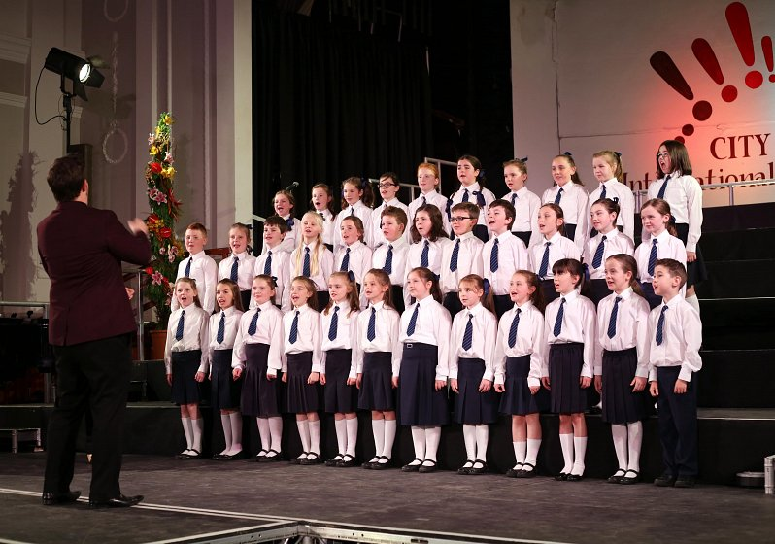
School Choir

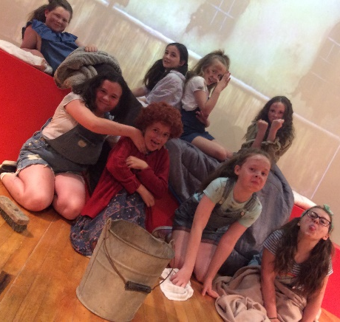
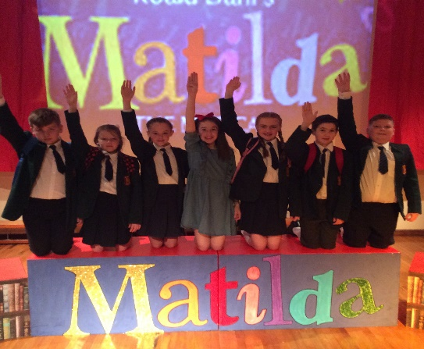
String Ensemble
Children from Primary 5 – 7 have the opportunity to learn a string instrument. This is an invaluable experience for the children and provides them with a sense of musicianship as well as the skills set of dedication, practice, determination and indeed performance.
Annie

School Productions
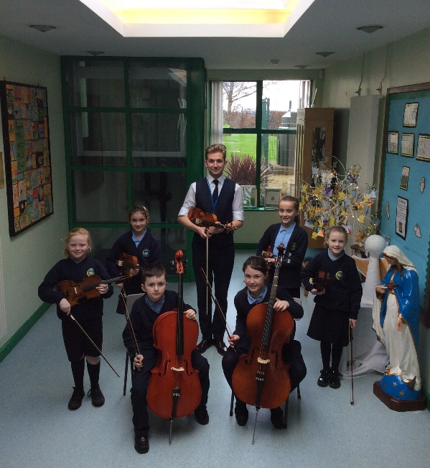
Our school has a long history of staging a variety of annual school productions both at Christmas and also in Term 3. All children from P1-P7 take part and they get a real taste of performance, whether through drama, music, art or dance. Their involvement both behind the scenes and on stage gives them a great insight into the Arts and develops the talents of all our children, encouraging them to be the best that they can be.

