Principal: Mrs J.O’Donnell info@faughanvale.derry.ni.sch.uk Tel 02871810529
5thMay 2023

We would like to wish our P4 class every blessing when they make their First Holy Communion this Saturday 6th May at 10.00am in Star of the Sea. Choir members are asked to be at the chapel by 9.45am in school uniform.

We would also like to take this opportunity to thank our school choir for attending school and parish events throughout the year, and you the parents, for supporting this.

Reminder:
Monday 8th May is a Bank Holiday and school is closed.

Events for next week:

Tuesday
Singing / Guitar & piano
2-3 club P1 & P2
P2 Gaelic 2.00-3.00pm in Muga pitch
P3-P7 Gaelic 3.00-4.00pm in pitch
Wednesday
St. Canice’s football tournament (Boys) – during school
P1 – P7 Skill school (football)
P6 Transfer Club 3-4.15pm
Thursday
Football club
P7 Show practice

Footballing Success!!!!

Our girls and boys football teams participated in the first round of the Limavady Schools Blitz playing games against other local primary school teams. A great afternoon of football!!! Round 2 on the 17th May.
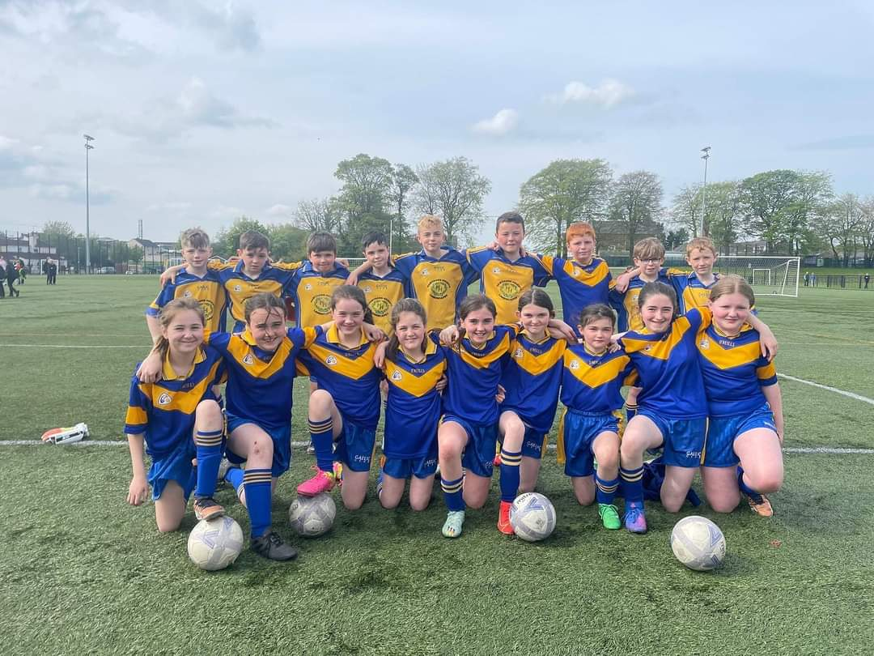

St. Canice’s Girls’ Football Competition

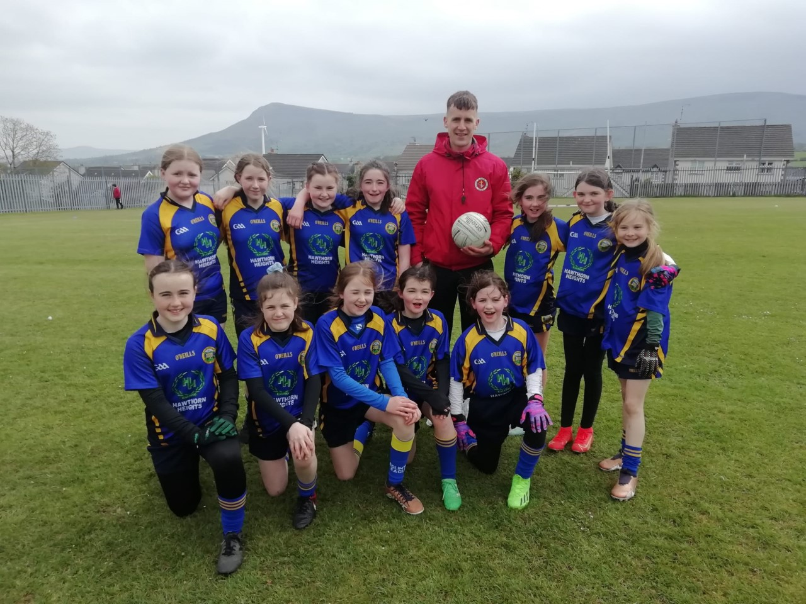
Well done to our Girls’ Gaelic Team who participated in the St. Canice’s Dungiven Girls’ Gaelic Football Tournament this week. They even had time to get some tips from Derry’s Country Star Mr. Shane McGuigan.

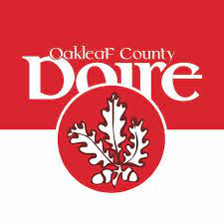
As Derry are in the Ulster Final on Sunday next we will have a ‘Red & White’ Day next Friday 12th May to show our support

SKILL SCHOOL DANCE
This club begins on WED 17TH May – Sign up for this club for 6 weeks via Skill School website. The cost is subsidised by the school & this has greatly reduced the price to £12 for the 6 weeks. This club is open to all classes P1-P7

Out of Schools Club:
3.00pm - 5.00pm for all pupils P1 – P7.
This will now run as two separate sessions each day to allow more flexibility for parents.

3.00pm – 4.00pm (inclusive of a snack) at a cost of £3.00
4.00 - 5.00pm at a cost of £3.00
3.00-5.00pm total cost of £6.00

Due to the changes ParentPay will be used as a booking system, whereby you book 1 or 2 sessions per day and bills will be issued on a Friday for the week. Please email office to confirm bookings info@faughanvale.derry.ni.sch.uk

